Assignment 1
Student Name: Mary Babu
Course: Big Data 1
Instructor: Prabhpreet Sidhu
Date: October 16, 2025

Contents
Introduction 2
Data Cleaning 3
Exploratory Data Analysis (EDA) 5
1. Tactic Analysis: 5
2. Platform Analysis 7
3. Campaign spend Analysis: 9
4. Trend Analysis 11
Key insights 12
Recommendations 13
Conclusion 14

Introduction
The main purpose of this assignment is to study Kroger’s marketing dataset and understand how the company spent money on different campaigns, platforms, and tactics. The analysis helps find which areas received the highest and lowest spending and how the spending changed over time.
The work was done using Python, mainly with the Pandas, Matplotlib, and Seaborn libraries. The data was first cleaned and then analyzed through charts to find patterns and trends. The final goal is to give useful insights and suggestions that can help Kroger plan its marketing budget more effectively.

Data Cleaning
Before analyzing, the dataset was cleaned to make it ready for use. Some values had dollar signs and commas, which were removed to make the “Spend” column numeric. The “Dates” column was converted into a proper date format, and a new column for “Month” was created to study spending by time period.
The key cleaning steps were:
- Removed unwanted symbols such as dollar signs ($) and commas (,) from the “Spend” column.
- Converted the “Spend” column into numeric format to enable accurate calculations.
- Standardized the “Dates” column to a proper date format using the datetime function.
- Extracted month information from each date to study monthly trends.

Codes used:
import pandas as pd
import matplotlib.pyplot as plt
df = pd.read_csv('/Workspace/Users/n01735817@humber.ca/Kroger_CSD.csv')

# Clean the 'Spend' column
df['Spend'] = df['Spend'].replace(r'[\$,]', '', regex=True).astype(float)
# Convert 'Dates' column to date format
df['Dates'] = pd.to_datetime(df['Dates'], format='%m/%d/%Y', errors='coerce')
# Extract month from date
df['Month'] = df['Dates'].dt.to_period('M').astype(str)
# Show first few rows to confirm
print(df.head())

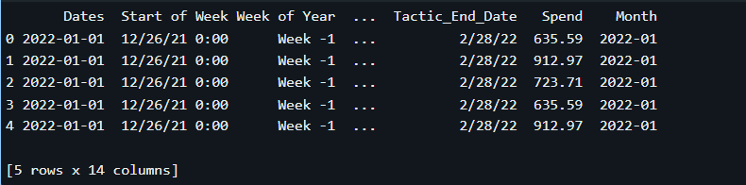
After cleaning, the dataset was checked for missing or invalid values. This ensured that only accurate and consistent data was used for further analysis.
print("Missing values per column:")
print(df.isnull().sum(), "\n")

Exploratory Data Analysis (EDA)
Exploratory analysis was conducted to understand how spending was distributed and to identify key patterns. The main areas of focus were tactics, platforms, campaigns, and monthly trends.

Tactic Analysis:
This part analyzed which marketing tactics received the highest and lowest total spend. The tactic “Digital Media Offsite Non Retailer Owned” had the highest total spend, while “Traditional Media/Outdoor” had the lowest.
- Top Total Spend by Tactic:
tactic_spend = df.groupby('Tactic')['Spend'].sum().reset_index().sort_values(by='Spend', ascending=False)
print("Top 5 Tactics by Spend:")
print(tactic_spend.head(), "\n")

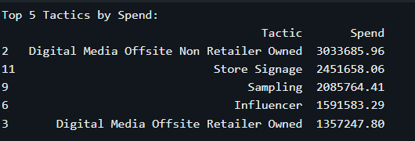

- Lowest Total Spend by Tactic:
print("Lowest 5 Tactics by Spend:")
print(tactic_spend.tail(), "\n")

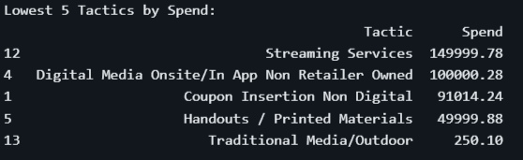

- Visualization
A horizontal bar chart was used for clarity:
import seaborn as sns# Plot spend by tactic
plt.figure(figsize=(12, 8))
sns.barplot(data=tactic_spend, y='Tactic', x='Spend')
plt.title('Total Spend by Tactic')
plt.tight_layout()
plt.show()

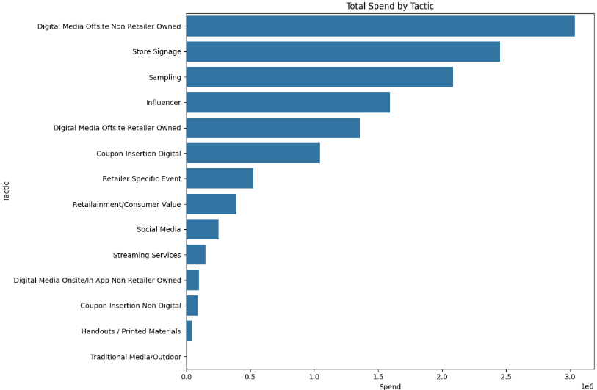

- Platform Analysis
The platform analysis identified where the marketing budget was most heavily invested.
- Highest Spend Platform: Keurig K-ICED Essentials (Kroger only)
- Lowest Spend Platform: Clamato Lent

- Top 5 platforms by spend
platform_spend = df.groupby('Platform')['Spend'].sum().reset_index().sort_values(by='Spend', ascending=False)
# Display top and bottom platforms
print("Top 5 Platforms by Spend:")
print(platform_spend.head(), "\n")

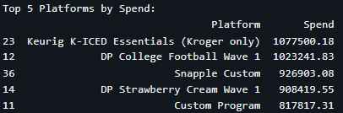

- Lowest 5 platforms by spend
print("Lowest 5 Platforms by Spend:")
print(platform_spend.tail(), "\n")

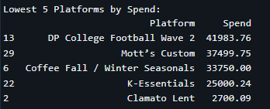
- Visualization
plt.figure(figsize=(12, 8)) # Increased figure size for better visibility
sns.barplot(data=platform_spend, y='Platform', x='Spend') # Swapping X and Y
plt.title('Total Spend by Platform')
plt.tight_layout() # Ensures everything fits
plt.show()

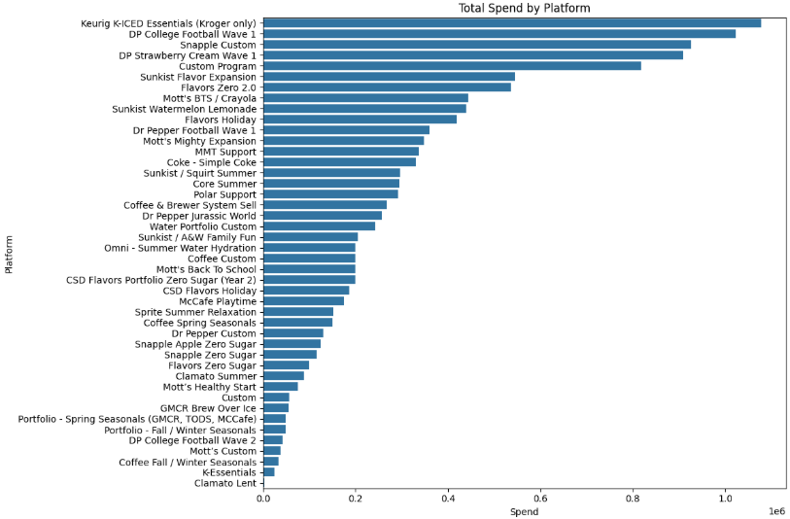

Campaign spend Analysis:
Campaign-level analysis helped determine which specific campaigns used the most and least funds.
- Highest Spend Campaign: Iced Platform Launch (KIE and Pods)_Kroger
- Lowest Spend Campaign: Clamato Lent

- To Display top campaigns
print("Top 5 Campaigns by Spend:")
print(campaign_spend.head(), "\n")

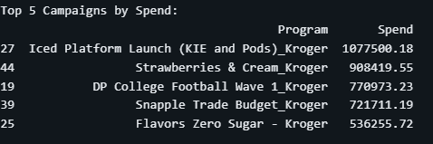
- To display lowest campaigns
print("Lowest 5 Campaigns by Spend:")
print(campaign_spend.tail(), "\n")

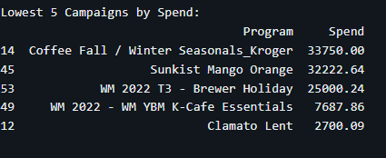

- Visualization
plt.figure(figsize=(12, 8)) # Increased figure size
# Swap x and y: 'Program' (labels) goes on the y-axis, 'Spend' (value) goes on the x-axis
sns.barplot(data=campaign_spend.head(10), y='Program', x='Spend')
plt.title('Top 10 Campaigns by Spend')
plt.tight_layout() # Ensures all program names are fully visible
plt.show()

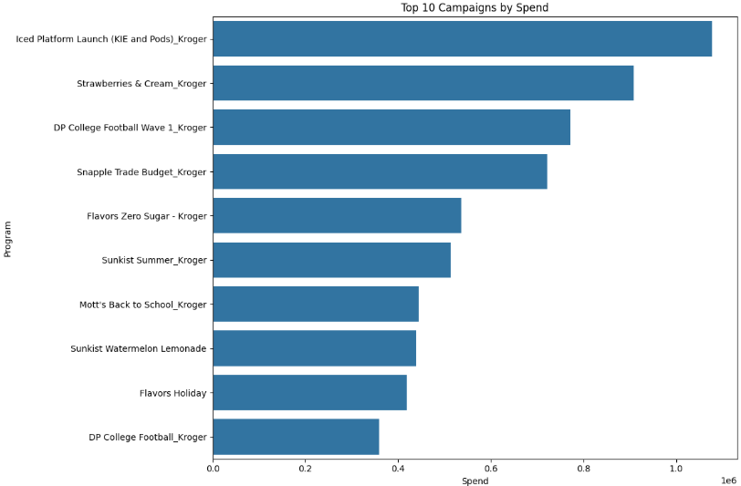

Trend Analysis
To identify overall spending patterns over time, the monthly spending totals were analyzed.
The trend chart showed that certain months had higher investments, likely due to seasonal marketing pushes or product launches.
# Calculate total spend per month
monthly_trend = df.groupby('Month')['Spend'].sum().reset_index()
# Plot trend
plt.figure(figsize=(12,6))
sns.lineplot(data=monthly_trend, x='Month', y='Spend', marker='o')
plt.title('Monthly Spend Trend Over Time')
plt.xticks(rotation=45)
plt.tight_layout()
plt.show()

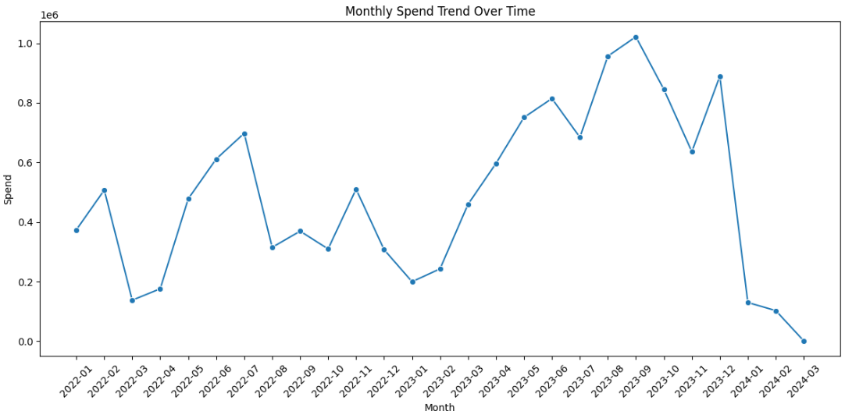

Key insights
From my analysis, several major spending patterns were found:
- Highest Spend Tactic: Digital Media Offsite Non Retailer Owned saw the biggest investment at $3,033,685.96.
- Lowest Spend Tactic: Traditional Media/Outdoor had the smallest cost, at just $250.10.
- Highest Spend Platform: The platform for Keurig K-ICED Essentials (Kroger only) received the most money: $1,077,500.18.
- Lowest Spend Platform: The Clamato Lent platform had the lowest spend at $2,700.09.
- Highest Spend Campaign: The largest project was the Iced Platform Launch (KIE and Pods)_Kroger at $1,077,500.18.
- Lowest Spend Campaign: The smallest project was Clamato Lent at $2,700.09.
This shows that the budget is heavily focused on digital advertising and specific, large campaigns partnered with retailers. Traditional and smaller campaigns receive very little funding.

Recommendations
Based on the analysis, the following recommendations are proposed:
- Increase investment in high-performing tactics and platforms such as digital and offsite media that show strong engagement.
- Reallocate funds from low-performing tactics (like traditional outdoor media) to digital or retailer-owned channels.
- Monitor monthly trends to better manage budget allocation during high and low marketing periods.
- Leverage data insights to plan seasonal or promotional campaigns strategically.
- Continuously track campaign performance to ensure budget optimization and improved ROI.

Conclusion
This analysis provided a clear understanding of how Kroger allocates its marketing budget across various channels. The findings show that digital marketing has the largest share of investment and impact, while traditional media plays a minor role.
By reallocating funds toward high-performing platforms and closely monitoring spending patterns over time, Kroger can enhance marketing efficiency and achieve better campaign outcomes.

